Political Survey Analysis State and Local Politics

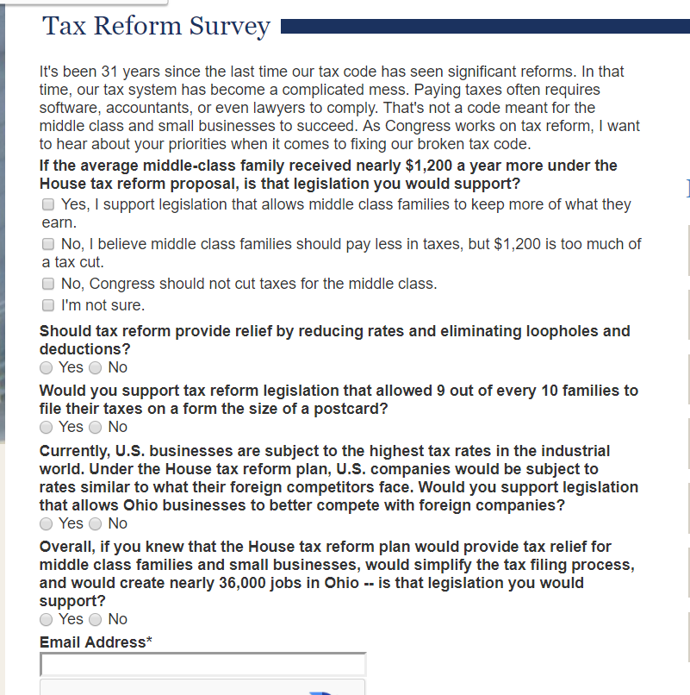

- What agenda is this survey trying to push, if any?
- Are the survey items biased in anyway? Wording?
- Can you identify any possible unsupported or misleading claims?
- How are key concepts defined/not defined in a way that might lead to bias?
- Can you identify any logical fallacies in the survey prompts/items?
- Given that this survey was posted on a Congressional website, how representative would the sample be of the general public?

