POLI 2901: Politics of Fascism in Pop Culture

J-term

CRN: xxxx
Instructor: Dr. John Alexander Curiel *please note I prefer to be called Dr. Curiel
Office & Mailbox Location: Hill 204B
Office Hours: MTWRF 12 - 1 PM
Appointments outside of regular office hours can also be requested. Virtual office hours can be conducted via the google hangout video chat with the email below.
E-mail: j-curiel@onu.edu

Course Description
The goal of this class is to understand the structural workings of fascism and its commentary in popular culture. Students shall learn both the ability to determine whether a piece of media touches upon fascism specifically versus some other form of totalitarian belief system, and whether said media condones or condemns the political belief system. The class therefore aims to serve both students with an interest in political commentary and creative writing/communication students who seek to increase their understanding and application to politics.
The umbrella of fascist beliefs can be difficult to categorize and identify given its often amorphous form, focus on “national spirit,” lack of material foundations, and existence of other types of totalitarian political regimes. However, discourse of fascism can likewise be difficult to group into satire/parody due to the generally accepted “reasonable person” subjectivity that separates, but can also be difficult to discern whether pieces of media endorse or condemn fascism. Therefore, the class learning goals are as follows:
1. Develop a working knowledge of the structural components of fascism present in all fascist systems
2. Distinguish fascism from other totalitarian governments via the triadic model of ideology and applied Explanation, Evaluation, Orientation, and Programmatic (EEOP) models of ideology
3. Identify the core aesthetics and terminology of pro-fascist messaging given the ideology’s core belief system
4. Understand the local/semi-subjective “reasonable standard” context that distinguishes endorsement of fascism from satires and parodies of fascism
5. Distinguish pieces of media with “fascist” elements by happenstance versus sincere fascist belief systems
6. Learn the media literacy necessary to engage in political discourse surrounding totalitarian belief systems as propagated by propaganda
Note that the underlying assumption of the class is that small-l liberal democracies are desirable and fascism antithetical to individual freedoms. Likewise, while we will critique the presence of other totalitarian regimes in passing, the focus shall be on the establishment and maintenance of fascist regimes. While students can and are encouraged to question assumptions and first principles, these will be the constant ones throughout the course.

Course Requirements

There is one required text for the course:
Stanley, Jason. 2018. How Fascism Works: The Politics of Us and Them. New York: Random House Books.
Spinrad, Norman. 1972. The Iron Dream. SF Gateway.
This is a popular-press book that condenses done some of the key indicators and features of fascism within modern politics. The book breaks down fascism into nine components that tend to be ever-present in all manifestations of fascism within the real world. For the purpose of creative writing students, different manifestations might arise given the world-building aspects of your story/world. For students without a strong background in political ideologies, the following textbook is recommended:

Ball, Terence and Richard Dagger. Political Ideologies and the Democratic Ideal. Pearson Publishing. (editions 3rd onward fine).

Figure 1: Triadic model of fascism: A shorthand to categorizing ideologies
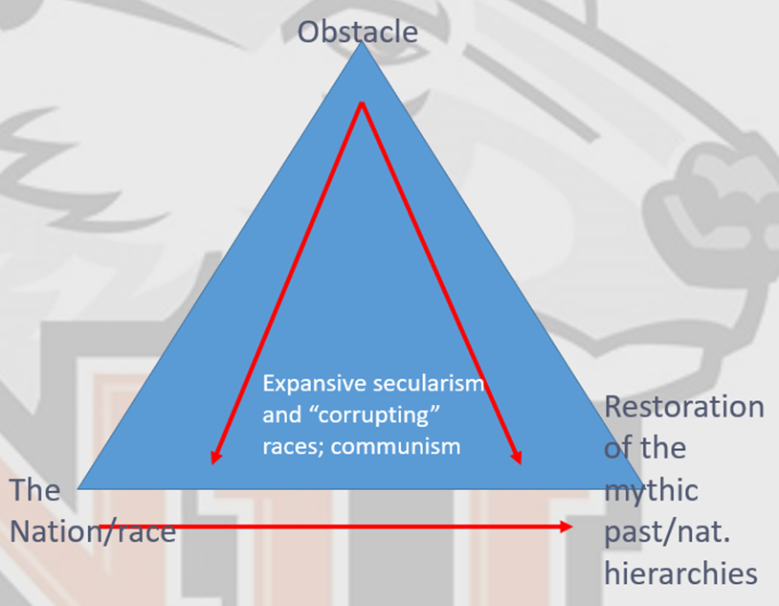

Figure 1 presents the synopsis of the core triadic model to ideology that can be used to roughly categorize most ideologies. The class shall review both the Stanley (2018) and Dagger and Ball pieces the first two days of class. Therefore, only students who feel they might need to catch up on ideology categories outside of class should feel the need to purchase the additional text. All other additional readings/viewings shall be provided on moodle or presented in class.

Assignments and Grading

Letter Grade | Percentage Score | Description
A | 90-100% | Superior grasp of subject matter with sound critical evaluations; evidence of extensive knowledge base. Completion of all assignments with accuracy and superior understanding of content.
B | 80-89.9% | Evidence of grasp of subject matter, some evidence of critical capacity and analytic ability; reasonable understanding of relevant issues; Completion of all assignments with accuracy and understanding of content.
C | 70-79.9% | Basic understanding of the subject matter. Ability to develop solutions to simple problems related to the course material. Completes all assignments with some accuracy and understanding
D | 60-69.9% | Some evidence of familiarity with the subject matter and some evidence that critical and analytic skills have been developed. Assignments completed, but lack complete understanding and/or accuracy
F | 0-59.9% | Little evidence of understanding of the subject matter. Assignments lack understanding, completeness, and/or accuracy.

The contributions of the various assignments to your final grade are as follows:

Book to movie critiques: 20%
Final report presentations: 15%
Participation: 30%
Final paper: 35%

Participation

Attendance and participation for every class is expected. Students are expected to come to class attentive and ready to discuss both the outside of class readings and in-class content. As a higher level j-term course on creative pop culture works, constant discourse, critical analysis and engagement is necessary. Course attendance shall be graded based upon combinations of class discussion and working group activities. In class participation will count for 30% of the grade. Each day of participation is graded out of five points.

Covid-19 pandemic note:
Given the presence of the COVID-19 pandemic and issues of tracking the virus, students are required to stay home in the event of illness. In order to earn full participation, please go to ONU medical and secure a doctor’s note. The doctor’s note shall then be used to count absences as excused, thereby backdating your absences and allowing you to save your unexcused absences for later. In the event of serious illness leading to 3 or more weeks of absences, students shall be allowed makeup assignments in order to ensure learning outcomes are achieved given the classes attended. Special accommodations are available for long term documented illness.
Book to movie critiques
Students will need to choose one of the book to movie/show comparisons discussed in class and write an analysis of how each covered political elements as related to ideology and fascism. The paper will involve noting how and why the changes that occurred highlighted or subsumed these ideological elements. Of special note is whether the piece maintained a straight up endorsement or critique of some ideological point, or if it instead shifted. These writing assignments should be at least 1000 words, with under a quarter of the paper a synopsis of the pieces themselves.
Final paper
Students will need to choose an outside piece of fiction for the purpose of conducting a critical analysis as to whether the piece engages in fascist ideological elements, and to what extent the piece is critical or endorsing the ideology. Students are expected to make use of both ideological models employed in class, the triadic and EEOP models. Following these, the students are expected to identify the core message of the piece within these models and determine the extent to which literary/artistic elements intentionally or by accident make an ideological point. These final papers should make some attempt to likewise consider the author’s background and socio-political environment to get at intentionality. A rubric will be provided, and students should be expected to decide upon a piece of fiction no later than the third day of classes.
Presentation
Students shall present their final paper findings in a 20 minute presentation. Additionally, these presentations should seek to implement pieces of their chosen piece of fiction into their presentation, in the form of movie clips, dramatic readings, projected images, etc.

Communication and grades
I communicate most efficiently via email. If you have general questions regarding absences, clarification regarding assignments or concepts, feedback, etc. I will do my best to respond asap. In the event that multiple students raise the same question, I will respond via a class-wide moodle email addressing the point of concern in place of an individualized email. Please note that I do not prioritize or often even respond to emails regarding grade at the moment or grade complaints; these can be addressed in office hours.

Student Conduct

Ohio Northern University is dedicated to providing an equitable educational experience for all enrolled students. Universal course policies applicable to all courses can be found at the following link: https://my.onu.edu/registrars_office/policies. Specifically, this website includes the policies for the following topics:
• Academic Dishonesty Policy
• Academic Accommodations Policy
• ONU Health and Safety Policy
• Title IX Policy
• Diversity, Equity, and Inclusion Statement

Diversity, Equity, and Inclusion Statement

This course strives to be an inclusive learning community, respecting those of differing backgrounds and beliefs. This classroom aims to be respectful to all members regardless of the basis of race, color, sex, gender identity, transgender status, religion, national origin, age, disability, sexual orientation, marital status, military or veteran status, genetic information or any other category protected by federal, state, or local law. Please let your instructor know if you prefer to be called a different name other than what is provided on the class roster.

Rights under Bird Law
Students have no rights under bird law. However, the body of law within Ohio is highly complex and nuanced. To avoid the need to address such matters, please do not bring birds to class.

Schedule
Day | Concept | Readings
Jan. 5, 2023 | Structures of fascism – the triadic model and primary components | How Fascism Works intro - chapter 2
Jan. 6, 2023 | Aesthetics of fascism - will to power – analysis of will to power to the depravity of Game of Thrones | How Fascism Works chapter 3 - chapter 5
Jan. 9, 2023 | Contextualizing discourse - critical structures and role of parody and satire | How Fascism Works chapter 6 - chapter 8  The Onion amicus brief on parody (on moodle)
Jan. 10, 2023 | The fandom and fascism: where pop culture radicalizes | How Fascism Works chapter 9 - chapter 10  Osworth, A.E. “Fascist Fandom and Raging Incels: Tracing the Baffling Nerd-to-White-Nationalist Pipeline.” https://lithub.com/fascist-fandom-and-raging-incels-tracing-the-baffling-nerd-to-white-nationalist-pipeline/
Jan. 11, 2023 | Supermen and the Ubermensch: Fascism and comicbooks  Class movies: Watchman and Dark Knight Rises excerpts | Read Weldon, Glen. “Superheroes And The F-Word: Grappling With The Ugly Truth Under The Capes”  https://www.npr.org/2016/11/16/502161587/superheroes-and-the-f-word-grappling-with-the-ugly-truth-under-the-capes  Watchman comic excerpt  Frank Miller’s “Dark Knight” excerpt
Jan. 12, 2023 | Unreality, will to power, and co-optation: Fascism and the Matrix  Movie: The Matrix; Matrix 4 excerpts | Readings  Start Iron Dream, chapters 1 - 4  Nicholas Barber. “The Matrix’s male power fantasy has dated badly”  https://www.bbc.com/culture/article/20190319-the-matrixs-male-power-fantasy-has-dated-badly
Jan. 13, 2023 | “Paul did nothing wrong”: The troubling alliance between science fiction and fascism | Read Iron Dream chapters 5 - 8  Dune excerpts and Dune Messiah
Jan. 14, 2023 | From endorsement to parody: Two different takes of Starship Troopers  Movie: Starship Troopers  Class discussion on Iron Dream | Read:  Heinlein’s Starship Troopers book excerpts  Iron Dream chapters 9 - 14
Jan. 16, 2023 | Expelliarmus! (Dis)arming fascism in Harry Potter  Movie: Excerpts of Harry Potter and the Deathly Hallows | Read: Harry Potter excerpts; JK Rowling tweets  Aja Romano. “Harry Potter and the Author Who Failed Us.”  https://www.vox.com/culture/21285396/jk-rowling-transphobic-backlash-harry-potter
Jan. 17, 2023 | Libertad! Construction and Destruction of fascism  Movie: V for Vendetta | Read: V for Vendetta graphic novel excerpts
Jan. 18, 2023 | Does anime have a fascism problem? Aesthetics v Structural messaging  Movies/shows excerpts:  Attack on Titan  Full Metal Alchemist  Irregular Magic High School  Overlord | Read: Tom Speelman. “The fascist subtext of Attack on Titan can’t go overlooked.”  https://www.polygon.com/2019/6/18/18683609/attack-on-titan-fascist-nationalist-isayama-hajime-manga-anime  Familiarize self with plots of shows
Jan. 19, 2023 | Going full on grey: fascism as presented in the mud of totalitarianism  Movie: Cross of Iron | Turn in Final papers
Jan. 20, 2023 | Student presentations

Campus Resources

Disability Services & Academic Accommodations

If you are entitled to accommodations for a disability, please discuss them with your professor as soon as possible, preferably during office hours. It is the responsibility of the student to discuss his/her/their accommodations with the professor even if the disability services office sends the professor an e-mail. I am eager to help you in any way I can. For additional information about the services that ONU provides students, please visit: https://my.onu.edu/student_life/health_and_counseling.

Additionally, in the event of continual illness where special accommodations might need to be made, please contact Melissa Verb (m-verb@onu.edu) for accommodations across all your courses, and myself for this class specifically. The earlier that you reach out, the more time that we will both have to ensure that all progresses smoothly. Therefore, communication is key.

The Heterick Memorial Library
The Library is the ideal place for you to work on your research paper and find peer-reviewed sources. You are encouraged to seek out the assistance of Heterick’s librarians, either in person at the Reference Desk or via email at reference@onu.edu. For this course, speaking with a librarian about the topics you research could be a very productive use of your time, both as you begin the research process and as you finalize your searches in the library’s databases. They can help you find appropriate sources for your paper.

The university assigns all first-year students a personal librarian who can help you navigate the library and research topics for the assignments that you receive in any class. You can find your personal librarian by visiting:
http://www.onu.edu/academics/library/personal_librarian_program

The Writing Center at Heterick Memoiral Library
The peer tutors at the Writing Center offer free tutoring to help you work through any stage of the writing process from brainstorming to polishing a final draft. You can schedule an appointment for a 30 or 60-minute one-on-one tutoring session by going to Heterick 209, calling (419) 772-2186, or visiting https://onu.mywconline.com. To get feedback without an appointment: 1. Write in the online writing room where a tutor is available to answer questions as you work, 2. Request written comments on your writing, or 3. Email writing-related questions to writing-help@onu.edu. For more information about the Writing Center's services, visit: https://my.onu.edu/academics/resources/the_writing_center.
If you want to consult with a tutor but cannot make it into the Writing Center, you are welcome to email your questions to writing-help@onu.edu and a tutor will respond during normal tutoring hours. The Writing Center does not provide feedback or schedule appointments using this email address, but any questions you have about your writing or the writing process are more than welcome!

While I will always do my best to read over any drafts submitted early, I will take into consideration the feedback that you implement into your papers given a confirmed meeting with the writing center. This will result in some positive increase in your grade from what I otherwise would have given.

Can be bought digitally for under $5.00
Can be found on Abebooks for under $5.00.

