Process tracing activity: Political Science and the impact of Calling the Election on Turnout in the Florida panhandle, 2000 Presidential Election

Summary: During the presidential election of 2000, major media outlets called the Florida election for Al Gore, despite the race being to close to call and ultimately going to George W. Bush. Political commentator John R Lott wrote in the Philadelphia Inquirer and a Cato Institute Report that the early call for Gore cost Bush ~17,000 votes in the Florida panhandle, which still had an additional hour of voting left, given that the panhandle is in a different time zone from the rest of the state. Lott found these results using a quantitative technique called “difference-in-differences” regression analysis. Given the following claims, documents, and evidence, please conduct the following:

- Who appear to be the primary agents/actors/institutions within the scenario presented by Lott?
- What assumptions does Lott make in his analysis?
  - What data are used to come to the conclusion that he reached?
- Draw out the sequence/chain of events according to Lott’s argument
  - Identify the necessary conditions at each step
- What type of auxiliary indicators and instrumental tests arise given the competing theories?
- How might you go about testing each step that would necessarily need to occur according to Lott’s argument?
- What evidence on hand speaks to the likelihood of each step?
- How would you ascertain the ultimate validity of Lott’s theory?

NOTE: For extra structure, be certain to look back at your notes on the steps necessary to engage in process tracing. Give special consideration to “sensitivity tests”, i.e. being explicit on the range of potential outcomes that reflect the maximum effect that might be reached at a given stage.

Evidence document 1: An excerpt of the analysis by John Lott (with context provided)
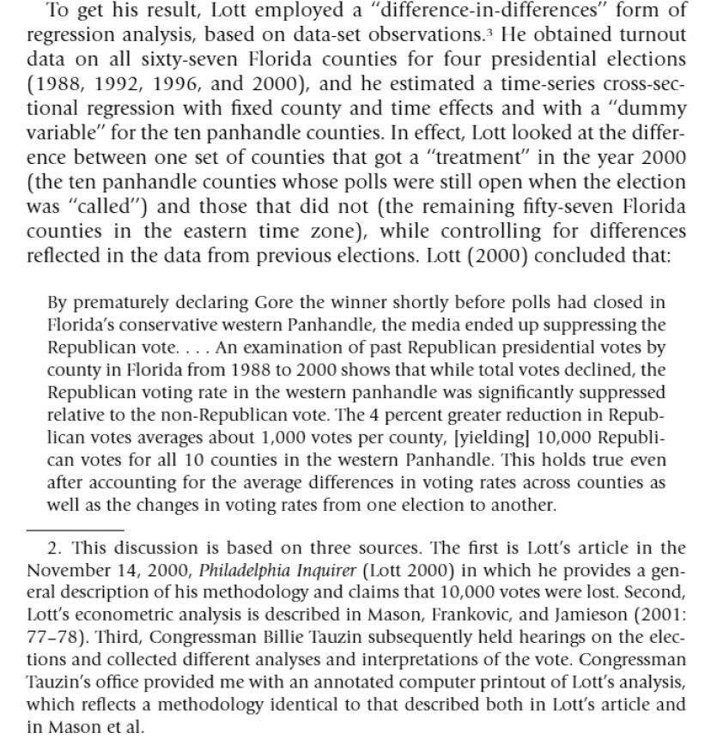

Evidence Document 2: Rationale of the principles behind Difference-in-difference tests, Columbia Public Health Stats department (https://www.publichealth.columbia.edu/research/population-health-methods/difference-difference-estimation)

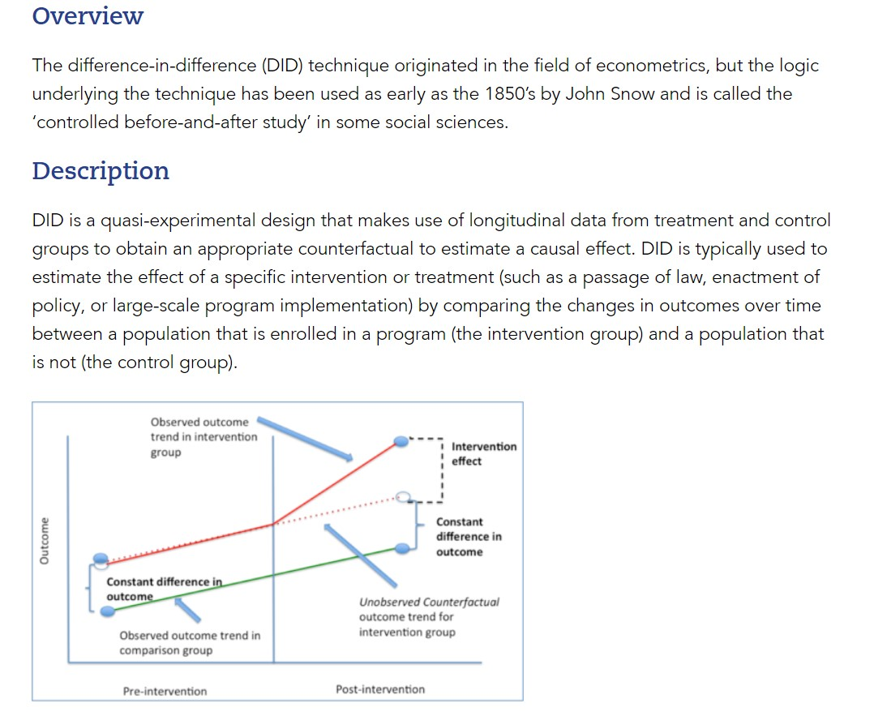
(Part 2 on assumptions on next page)


Evidence Document 3: Excerpt on voters left in the queue
Network television called the election in favor of Democratic presidential candidate Al Gore at approximately 7:50 PM EST, 10 minutes before polls closed within the Florida panhandle at 7:00 PM CST. Florida election offices allowed election day in-person voting from 7:00 AM to 7:00 PM, local time. In total, 303,000 voters cast their ballots on Election Day within the Florida panhandle. As per NBC interviews with county election officials within Florida panhandle counties, the County Election Director of Jackson County, FL, had this to say:
“Well, I definitely encourage people to turn out to vote no matter who you think is going to win, so I guess that I’m not thrilled y’all in the media called the election before it was truly over. I don’t recall any voters coming in ten minutes before polls close, ‘cept for my sister back in ’96 since I told her that no one would be there. Not the most fun thing waiting in line after all, as it’s not like you can watch television or anything like that. That said, you never know till you know, you know.”
Political scientist John Lott spearheaded the claims that up to 17,000 voters across the panhandle in favor of Bush refused to show up in tandem with a Cato Institute report. Studies are ongoing in identifying Bush loyalists who might not have showed up.
- NBC Report excerpt, Evening News

Evidence Document 4: Census Population Survey Voter supplement on times of voting, 1988 – 1996
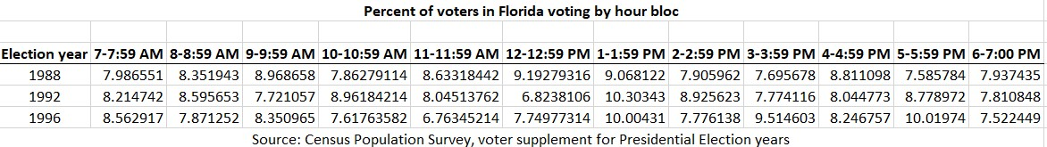

Evidence Document 5: Republican Vote Share in Last Two Presidential Elections

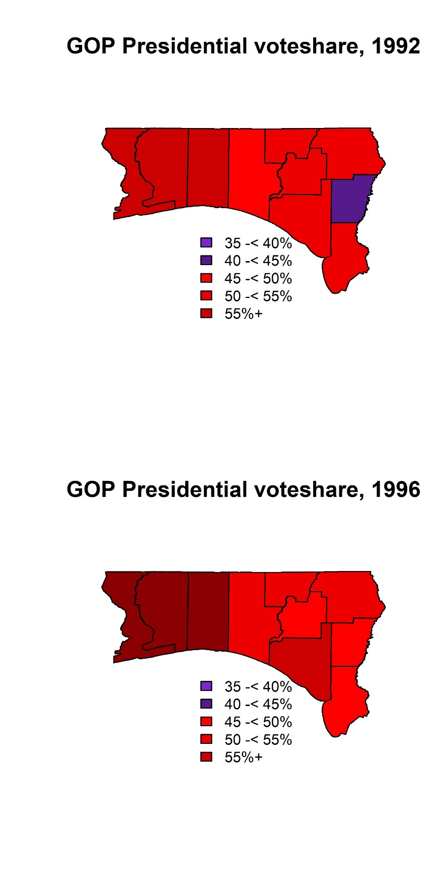

Evidence Document 6: Prior Studies on Media Effects in Decreasing Turnout
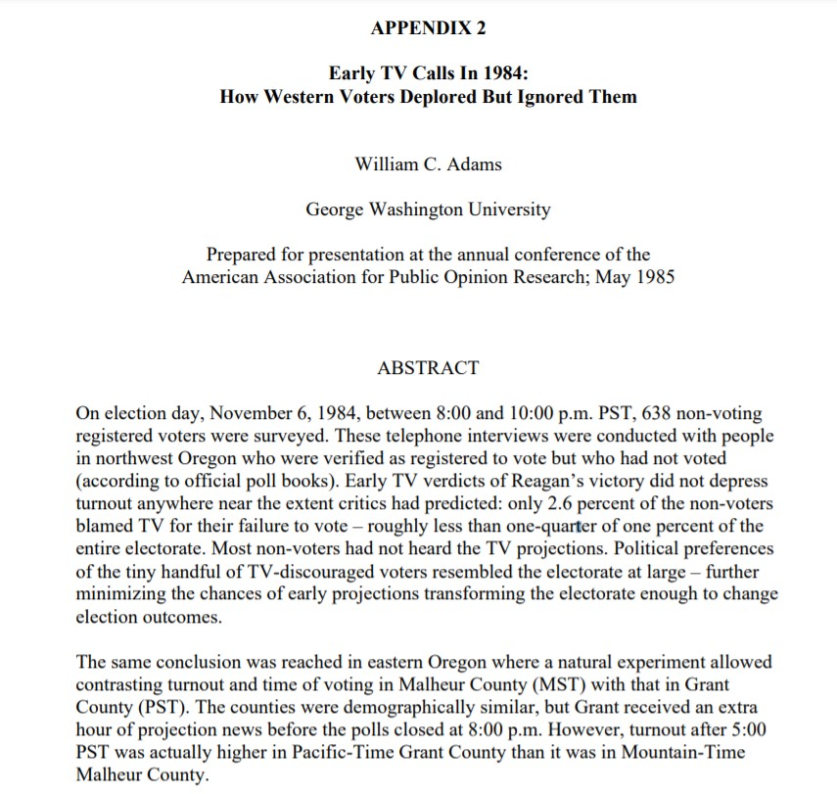

Addendum: The document is part of an appendix to a CNN report on improving election night calls. The report later estimates a height of 20 percent of adult viewers watching election night coverage during the late 1990s and early 2000s.

